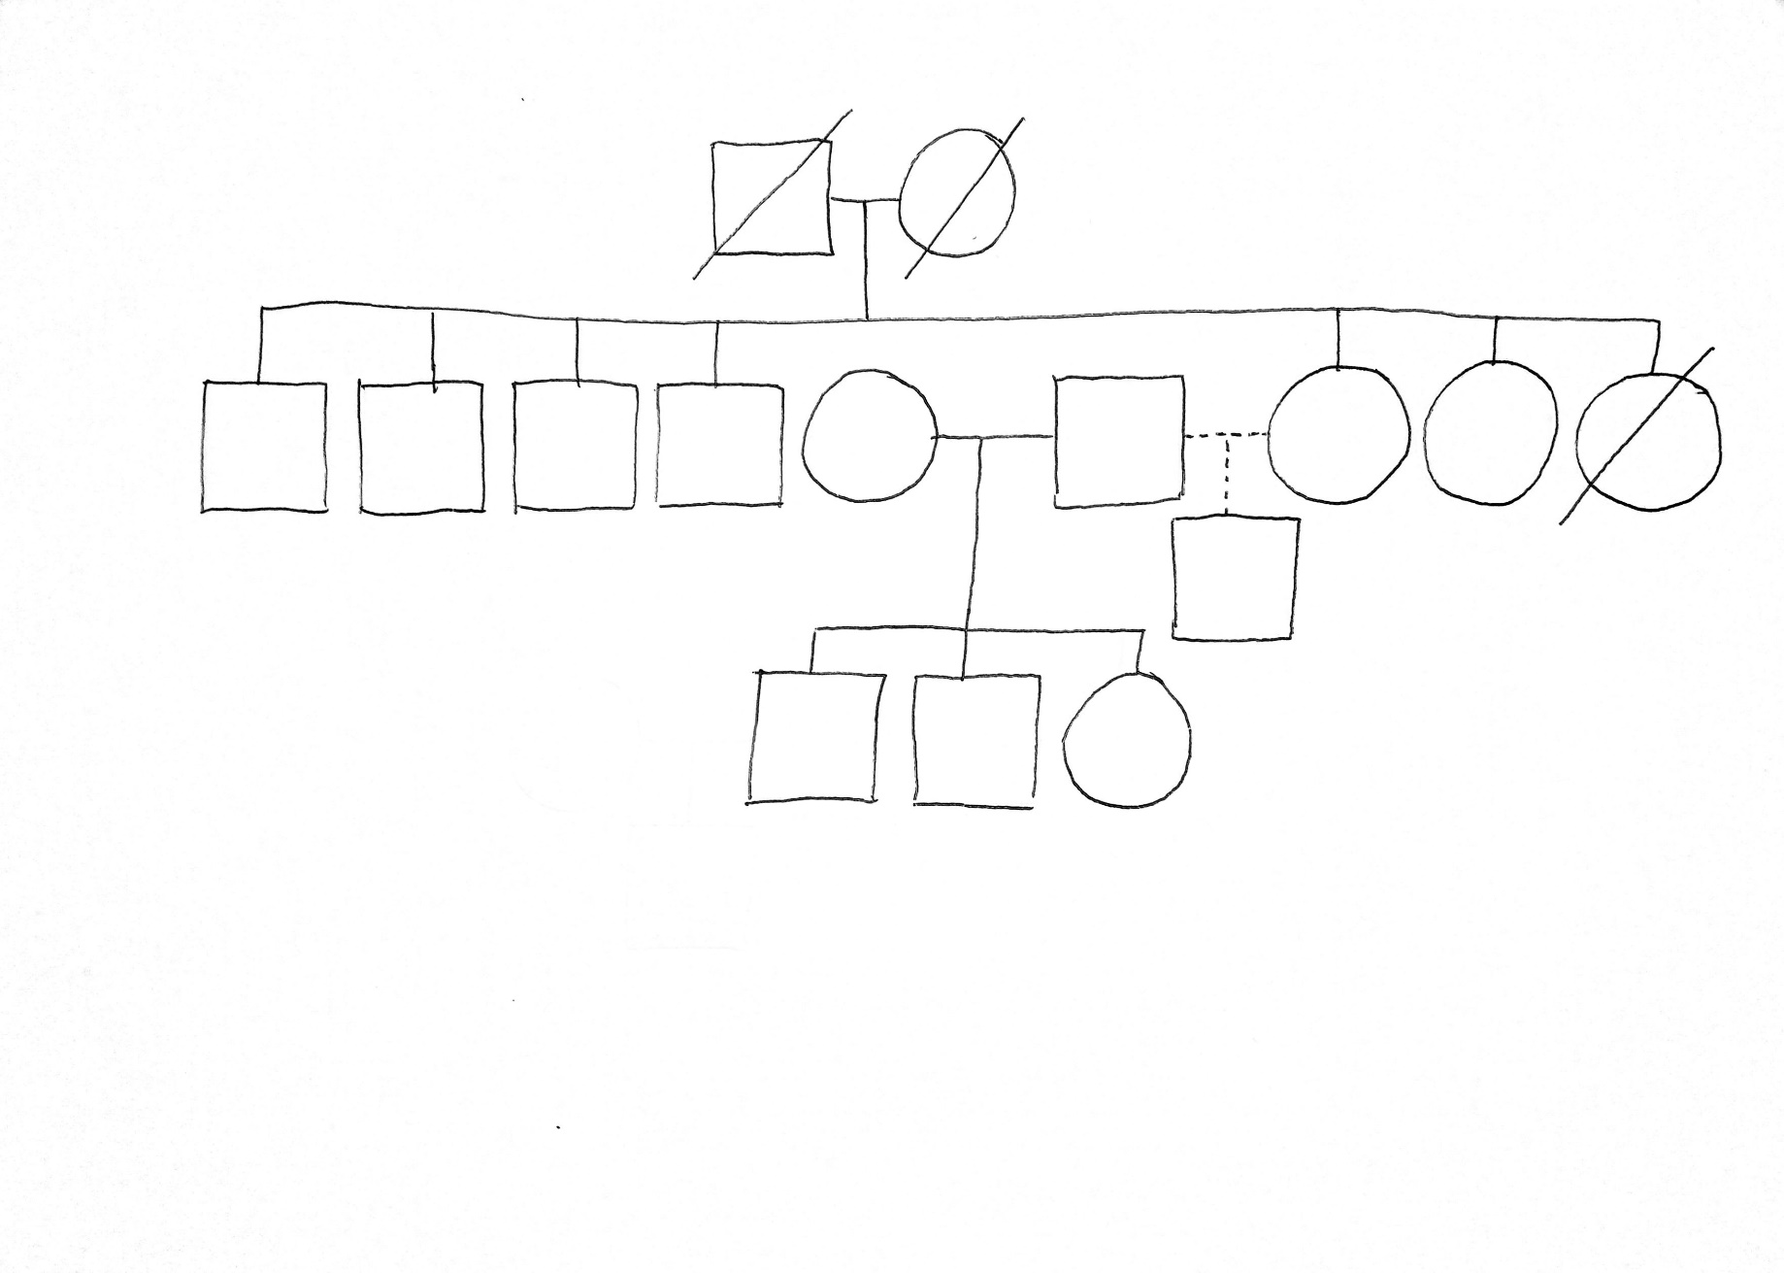


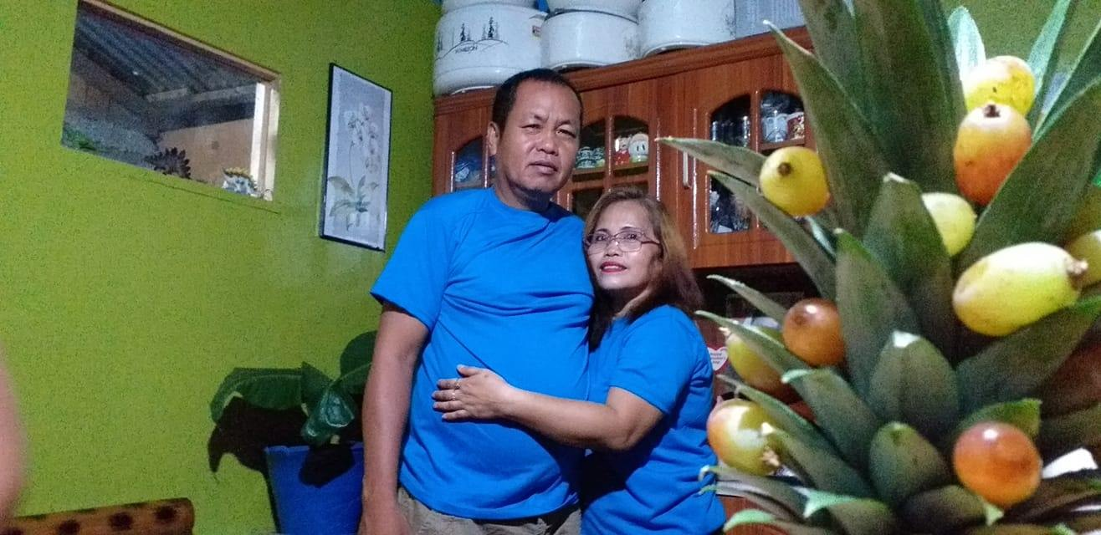
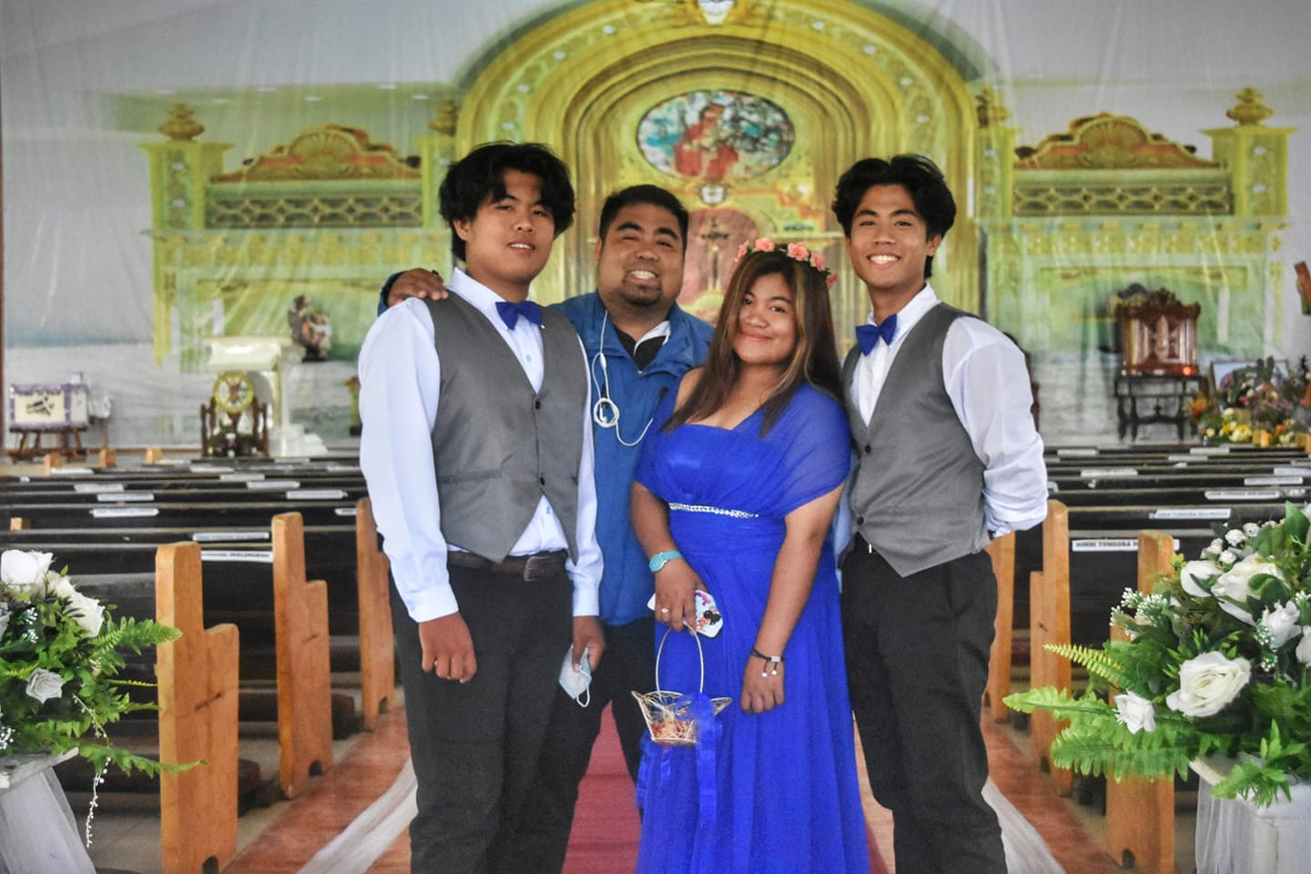
PEDIGREE ANALYSIS
ZULITA-DELAN FAMILY

ANALYSIS:
The trait I am tracing is the dominant trait of being curly or having a curly hair. My grandfather has curly and thick hair while my grandmother has straight, thin hairs. Together they have 8 children, 4 being male and 4 being female. The eldest son has been infected, the second hasn’t, the third fourth son, and the fifth daughter being my mother, the seventh daughter and the eight are all affected by the dominant trait and has curly hair, the only reason they don’t look curly in the picture its either they do have very short hair like the men aor they undergo hair treatment. My grandfather, grandmother and their youngest child are now dead and I don’t have pictures of them so I leave them blank. The dominant curly hair has been passed, down to the third generation being my brother. My father married my mother and had 3 children my brother, my sister and me. My father then had a child with my mother’s sister being my second brother. My mother is affected by the trait but my father is not curly so the trait that I have inherited is not being curly. And of course the recessive trait of my family from my mother’s side is having straight hair. (FOR THE SYMBOLS I USE SEE FIGURE 10 ABOVE.).

