Historical Sources
Keith Julius Z. Bautista BSBio2A March 13, 2021
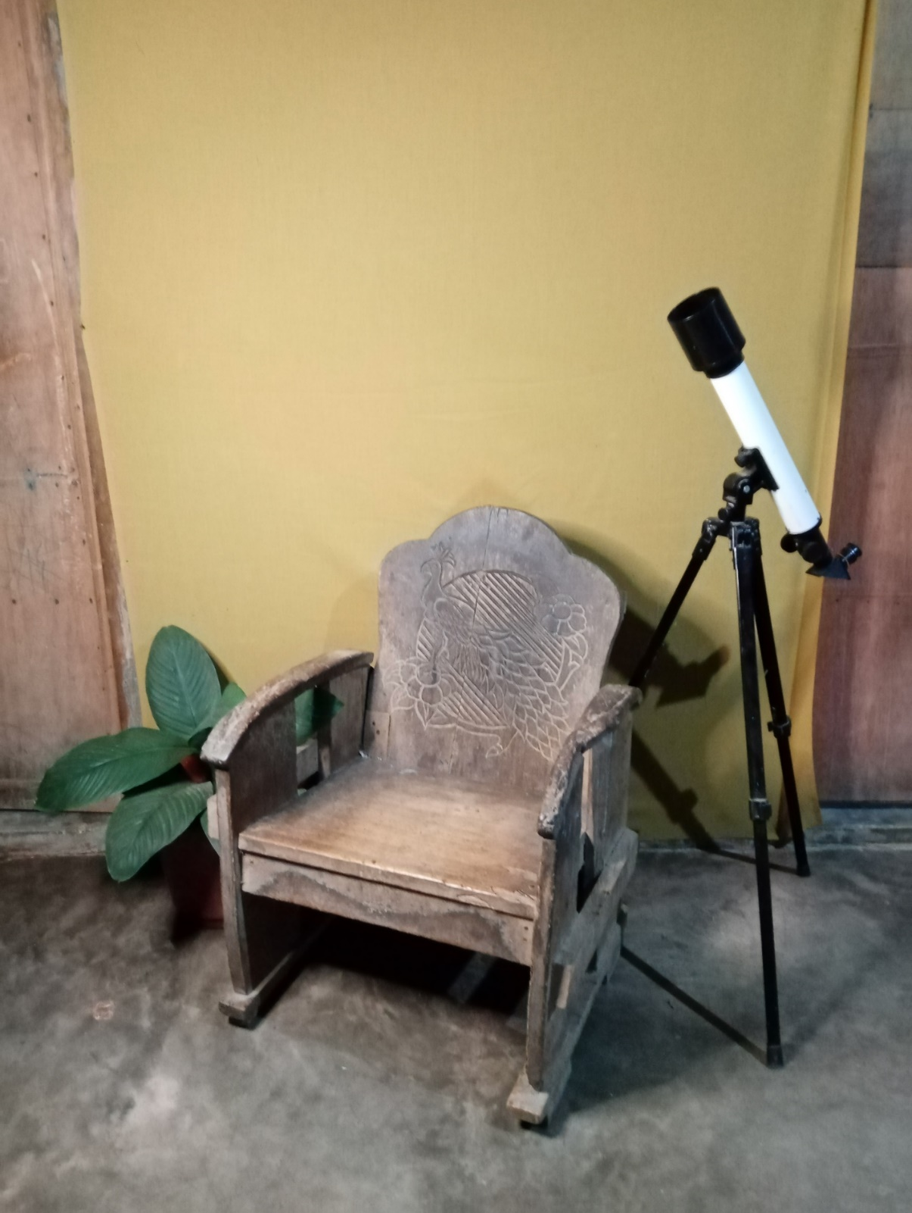

Historical Sources

How can you tell if something is historical? Or if something is of worth? A historical object is something from the earlier times, an object that is relevant in that specific period of time. An object that serves as an evidence of the existence of time itself. Most people may find old things as junk, worthless, or meaningless. And few people may find them somewhat interesting, fascinating, wonderful. Historical objects are like a scent from the past that lingers to bring back memories or it could be like a scope to look to the past, to perceive the sensation of actually being there. In that moment of time. Not all things from the past bring those feelings or be relevant to the present but certain objects do.
The chair you are looking at have been passed down to almost four generations. Surviving the last 50 years of human activities. That chair was being bought by my grandfather back in the 1960’s, and for over 50 years it still stands. We do not have much furniture in our home and we tend to just sit on the floor, although we do have makeshift seats, but we don’t have enough seat to accommodate all of us. And whenever visitors came we offer them our seats and just sit on the floor. But in 2009 my grandfather gave that chair together with another two, to my father. Because he doesn’t use it anymore and they were just sitting in his stockroom collecting dust for over 3 years and he decided to give it to us rather to just throw it away.
I have 3 siblings and we tend to take seats from each other because there are only three seats with the backrest. And because of that chair we almost didn’t speak with my brother for almost a year just because of a taken seat. We were tied to the chair for almost two hours face to face just to reconcile the both of us, but out of pride and anger we didn’t and won’t. We only talk to each other again after 11 months, on his birthday and that is just because of our mother coming home from Dubai. And just like that, that chair is a part of us, something that remind us not to fight against little things. That chair taught me a lesson of others first before me. Although it is not applied for everything but after that our relation of my brother becomes much stronger and better.
Although objects cannot actually talk nor can feel anything, nor can express emotions. But that chair becomes a part of me that changes the way I am today. It’s like talking to me whenever I felt that I am too selfish. It reminds me all the time to give not just to offer seat when needed but also to tend to those who is needy. That chair may just be an object to another human being but that chair becomes a witness of our relationship as a brother. It is not the mere object itself that becomes the history but the story that is behind of it, the story that makes it history.

